1. **Gantt Chart**

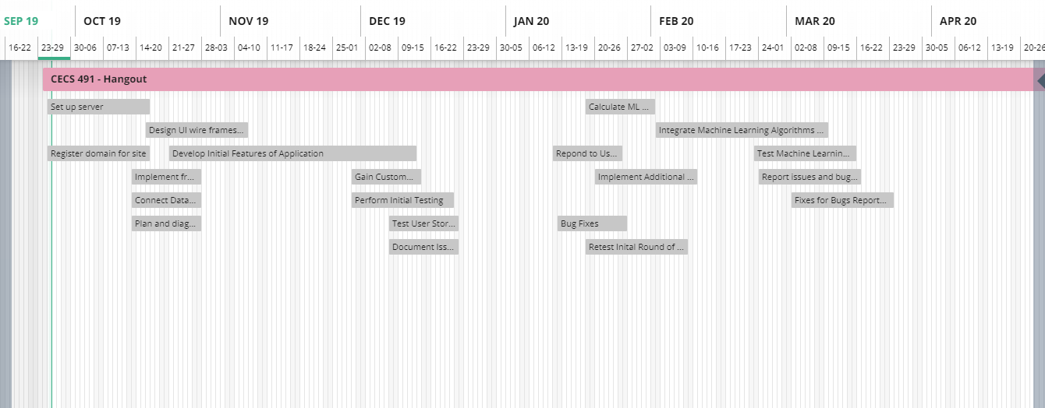

Our gantt chart is a loose planning of what stages of development we want to be at certain points during the year. In the first two to three sprints, we are focused on creating a core architecture and implementation of our product. We plan to implement all the required features first, then test and do bug fixes for the product at that time. Then we will conduct user analysis and surveys to plan what additional features would be preferred for our users, and decide what and how to implement for the next phase of our project. Later in the year we plan on calculating and implementing machine learning algorithms into our product, which will require additional testing.

1. **Project Tracking Matrix**

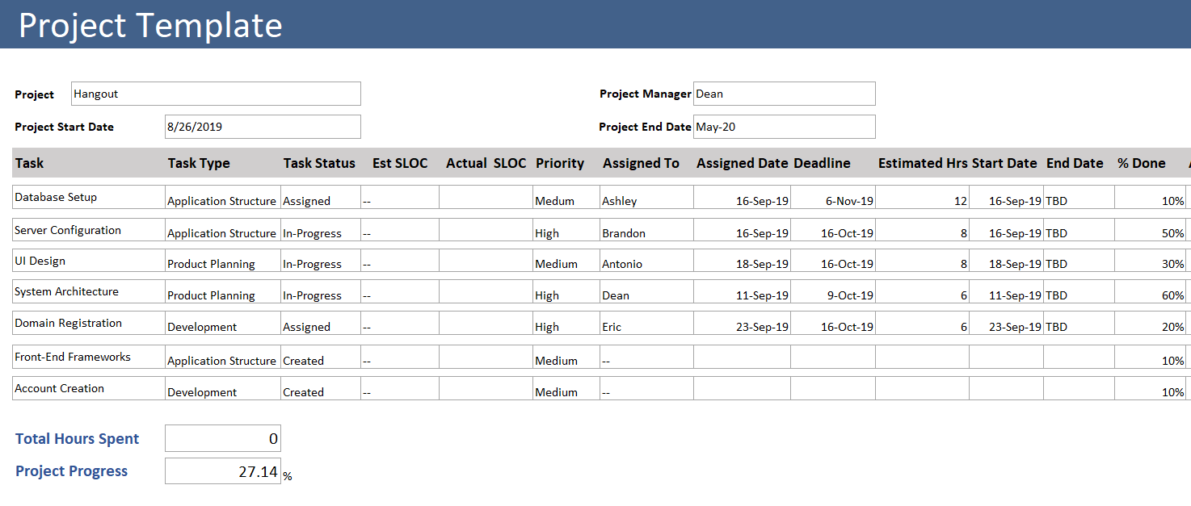

The project tracking matrix at this stage in our product development has focused on initial groundwork needed to begin writing code. We have not started writing any code, so we cannot at this time create a code development velocity calculation. At this time, we are focused on setting up the necessary components for our product. This includes; a database, server, domain, front-end, and back-end. We plan on using React and NodeJS, Firebase, and AWS for those respective components.

1. **Sprint Board**

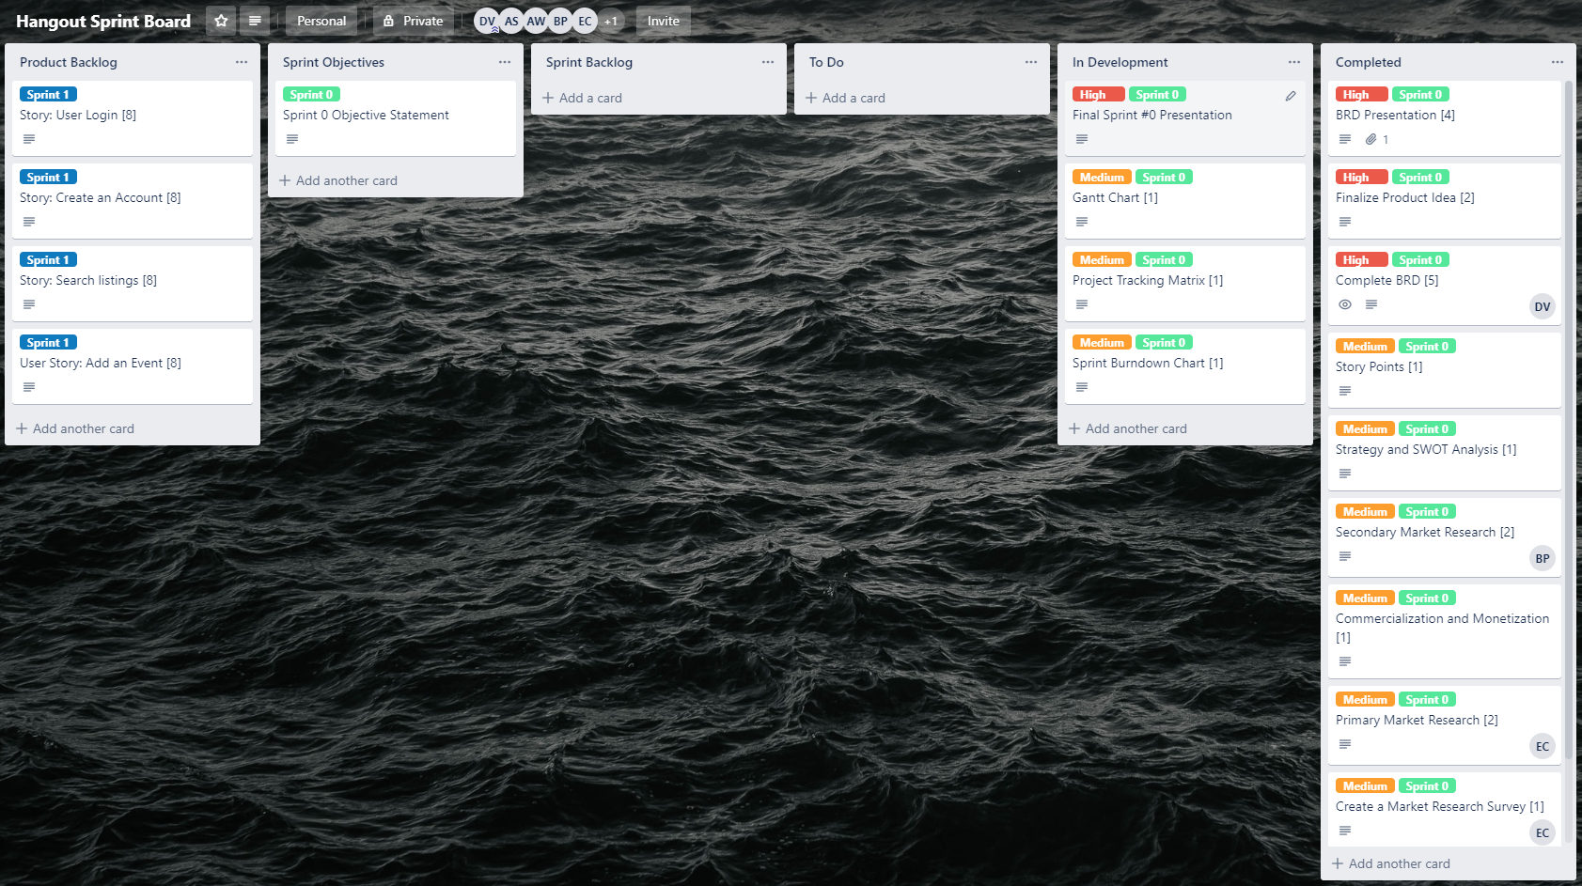

This is our sprint board, consisting of six sections; product backlog, sprint objectives, sprint backlog, to do, in development, and completed. All of these fields are straightforward in their function, and what cards are contained in each. Cards are labeled with a priority; low, medium, or high. Cards are also labeled with what sprint they are contained in, giving more ease in viewing the current progress in the sprint. Each card can be assigned to a member of the team, and each card is labeled in the title with the amount of story points assigned to it.

1. **Sprint Burndown Chart**

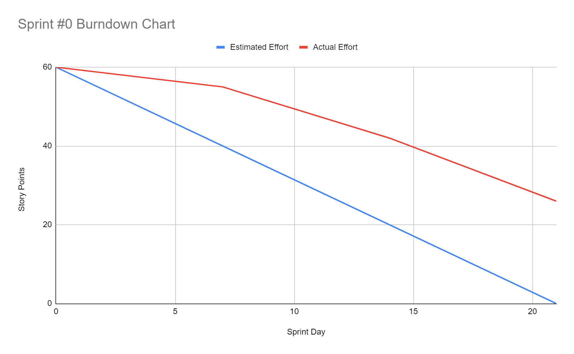

Our sprint burndown has shown that our actual effort has not matched our estimated effort for this sprint. The team sprint capacity for our team was calculated to be sixty hours. For our burndown chart, there are four points in the chart; beginning, end of week one, end of week two, end. This sprint we did not meet our estimated effort because of the nature of this sprint #0 to be a transitory sprint where we are learning agile processes and becoming more familiar with our responsibilities. The beginning of the sprint was not very productive, however the rate of story points being completed increased as the sprint went on. If we can continue this rate for the upcoming sprint, we would be in good shape.

1. **Sprint Retrospective**

*What worked well?*

Overall what went the best during this sprint was our growth as a team. Team chemistry has improved substantially, as well as communication and effort. Initially during the sprint, our communication and understanding of expectations was unclear. However, we now have a greater understanding of our roles, and agile, scrum process. Our team works best when our roles and responsibilities are clearly defined, and each team member has a definite understanding of what work they need to have accomplished.

*What could be improved?*

Improvement is needed in our ability to meet deadlines, work proactively, and our general efficiency. Early in the sprint we were very disorganized, missing deliverable deadlines, and falling behind in our work. The reason for this was partly because as new group members, we were unfamiliar with each other, causing a gap in our communication.

*What did not work well and should be removed?*

Something that is very apparent is that the group responsibilities must be clearly defined in order for our team to be the most productive. If the necessary tasks are not delegated and assigned properly, productivity will be severely diminished.

*What will we commit to doing in the next Sprint?*

This sprint #0 was mostly focused on becoming acclimated with the agile process, coming together as a team, and planning our product idea. The next sprint will be focused on transitioning from coming up with an idea, to making it happen. We will be committed to starting a product that we can start developing. We should have a working product every day, and at this point we have no product at all.

*Overall, what have we learned in this sprint?*

What we have learned in this sprint were all focused towards our team chemistry and how we should implement agile and scrum practices into our team. We learned how to have team sprint planning meetings, delegate work, and communicate our progress.